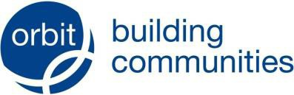
Statement on Modern Slavery & Trafficking: Transparency in the Supply Chain

This statement is intended to comply with the requirements of the Modern Slavery Act 2015 and sets out Orbit’s position. The statement is reviewed annually and formally approved by the Group Board.

Our General Position

We acknowledge and agree that Slavery and Forced Labour (as defined by Article 4 of the Convention on Human Rights) are rightly to be treated as offences and we recognise that in determining whether ‘slavery’ or ‘forced labour’ situations exist account must be taken of all the circumstances of the case including any vulnerability of the individual.

We acknowledge and agree that Human Trafficking is rightly to be treated as an offence and understand that Human Trafficking is the arranging of the transport of a person with a view to their being exploited or in the knowledge that they will be exploited. Exploitation is defined as:

- slavery
- forced labour
- sexual exploitation (defined by reference to other UK Acts)
- removal of organs
- securing services by force, threats, or deception
- securing services by any means from a child or vulnerable person (as defined)

As these things may happen within our “supply chain” i.e. be carried out by contractors, sub-contractors, sub-sub-contractors (and so on ) and/or suppliers, sub- suppliers, (and so on) we have a moral duty to do what we can to ensure we are not complicit, so far as we are reasonably able to do so.

In this context, Orbit does not operate in a high-risk environment, but we cannot be complacent. Visibility of our supply chain below “Tier 1” i.e. beyond those with whom we directly contract is limited and we are heavily reliant on those tier 1 contractors.

Although auditing supply chains can be difficult we have implemented a programme of site audits using a specialist firm on our behalf. Following the production of the commissioned reports, we will take a risk based pragmatic approach to continuing this exercise, having due regard to resources needing to be prioritised to service delivery.

- Group Structure, Business & Supply Chains

Our Group Structure is outlined in Appendix 1.

Our supply chains cover Goods, Services and Works necessary to:

  - Deliver front line services to the residents in properties we manage
  - Build new homes

  - Support the “back-office” services that keep the business operating

Our procurement activity is governed by the Public Contracts Regulations and our own internal Standing Orders which require formal quotation or tenders for all higher value purchases.

- Policies in Relation to Slavery and Human Trafficking

We do not have a specific policy on Slavery & Human Trafficking and do not believe that a policy with such a narrow focus is appropriate for an issue which cuts across the whole business is appropriate.
Our overarching “Supplier Management Policy” includes the following section on ethics:

Ethics – we expect our suppliers to act in an ethical manner in the conduct of their business. This includes (so far as is practicable and having regard to the size of their organisation and scale of operation)

  - monitoring their own supply chain and reporting in line with the Modern Slavery Act;
  - include in all subcontracts payment terms in accordance with Regulation 113 of the Public Contracts Regulations 2015, where this has been embedded in the contract, and in all other cases to ensure fair payment terms are adopted and complied with;
  - not to discriminate on the basis of any of the characteristics listed in the Equalities Act 2010 in either employment or service delivery practices;
  - in the case of Contractors and Consultants to commit to Orbit’s relevant Code of Conduct;
  - to comply with all Health & Safety and welfare laws; and
  - to have a robust anti-bribery and anti-corruption policy in compliance with The Bribery Act 2010.

This is supported by a whistle-blowing policy to protect staff and board members in the event of them raising concerns.
At this stage we do not envisage specific performance indicators in this area unless a high-risk is identified, which can be cost-effectively monitored and influenced.

- Training for Staff

Key members of the Procurement Team are MCIPS qualified and are encouraged to take the CIPS Ethics Training and Test which covers all the relevant aspects.

Approved by the Group Board on 18/7/2023.

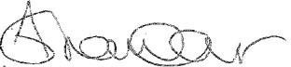
Signed by ………………………………………………………………………………………….

Director of Business Assurance

Appendix 1

Our Structure

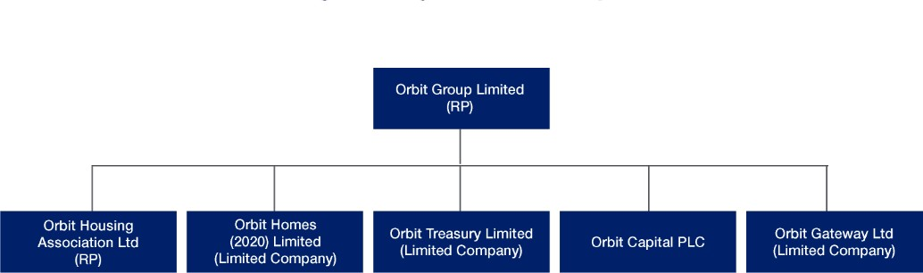

Orbit operates a Group structure which ensures control, local accountability, and direct engagement with our customers. Our approach is to maximise the potential of the Group structure to drive economies of scale and support our service aims.
Our Group legal entities are Orbit Group Limited, Orbit Housing Association Limited, Orbit Homes (2020) Limited, Orbit Treasury Limited, Orbit Capital plc and Orbit Gateway Limited. Group members collaborate in agreeing our strategic direction and values to achieve a shared vision, for the benefit of our customers and the Group as a whole.

Orbit Group Limited is the Group’s parent company, owns our shared ownership homes and provides strategic and corporate support services to the Group.

Orbit Housing Association Limited is our operating association and manages our homes across the Midlands, East and the South East.

Orbit Homes (2020) Limited is the development and sales arm of the Group and has increased the range of tenures we can provide for our customers. It specialises in building new homes for Market Rent, Market Sale, Shared Ownership and Affordable Rent.

Orbit Treasury Limited is a special purpose vehicle created to co-ordinate borrowing across the Group and offer advantageous interest charges to Group members. It is used to raise and manage the private finance needed to meet the Group’s funding requirements.

Orbit Capital plc is a public limited company established to receive the proceeds of bonds issued on behalf of the Group.

Orbit Gateway Limited – Orbit Gateway Limited is used for commercial or other opportunities where there are tax and other benefits in holding/operating these through a separate wholly-owned subsidiary. It is not trading currently but is being used as the vehicle for Orbit’s Community Investment Partnership with other RPs.

